 

|  |
| --- |
| **FPT-aptech computer education** |
| Use Guide Document |
| Mantech Helpdesk |
|  |
| |  |  | | --- | --- | | **Group 1** | | | **Group Member** | Nguyen Xuan Minh, C00174, 3391  Bui Huy Phong, C00119, 0141  Nguyen Thanh Nam, C00078, 0192  Nguyen Duc Viet, C00167 , 0204  Dao Anh Toan, , 0159 | | **Instructor** | Nguyen Ngoc Tu | | **Batch** | C0812I | | **Semester** | 4 | |
|  |

|  |
| --- |
|  |

Contents

[Admin 5](#_Toc303514300)

[Add new article 5](#_Toc303514301)

[Add department 7](#_Toc303514302)

[Add FAQ 9](#_Toc303514303)

[Add thread 11](#_Toc303514304)

[Add user 13](#_Toc303514305)

[Add complaint 15](#_Toc303514306)

[Change password 17](#_Toc303514307)

[Disable & enable article 20](#_Toc303514308)

[Disable & enable department 21](#_Toc303514309)

[Disable user 22](#_Toc303514310)

[Edit article 23](#_Toc303514311)

[Edit department 25](#_Toc303514312)

[Edit FAQ 27](#_Toc303514313)

[Edit profile 29](#_Toc303514314)

[Edit thread 31](#_Toc303514315)

[Edit user 33](#_Toc303514316)

[Enable & disable user 35](#_Toc303514317)

[List article 36](#_Toc303514318)

[List department 37](#_Toc303514319)

[List FAQ 38](#_Toc303514320)

[List thread 39](#_Toc303514321)

[List user 40](#_Toc303514322)

[Login 41](#_Toc303514323)

[Reset password 42](#_Toc303514324)

[View article 44](#_Toc303514325)

[View department 45](#_Toc303514326)

[View FAQ 46](#_Toc303514327)

[View profile 47](#_Toc303514328)

[View thread 48](#_Toc303514329)

[View user 49](#_Toc303514330)

[Employee 50](#_Toc303514331)

[Add new complaint 50](#_Toc303514332)

[Add new FAQ 52](#_Toc303514333)

[Like & dislike article 54](#_Toc303514334)

[List article 55](#_Toc303514335)

[List complaint 56](#_Toc303514336)

[List department 57](#_Toc303514337)

[List FAQ 58](#_Toc303514338)

[List thread 59](#_Toc303514339)

[Set complaint to finished 60](#_Toc303514340)

[View article 61](#_Toc303514341)

[View answers of complaint 62](#_Toc303514342)

[View complaint 63](#_Toc303514343)

[View department 64](#_Toc303514344)

[View FAQ 65](#_Toc303514345)

[View thread 66](#_Toc303514346)

[Technician 67](#_Toc303514347)

[Add new answer to complaint 67](#_Toc303514348)

[List complaints 69](#_Toc303514349)

[Disable & enable answer 70](#_Toc303514350)

[Edit answer 71](#_Toc303514351)

[View answer 73](#_Toc303514352)

[View complaints 74](#_Toc303514353)

# Admin

## Add new article

1. Click Create button

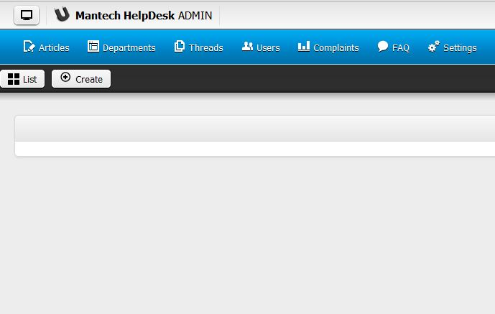

2. Input article information

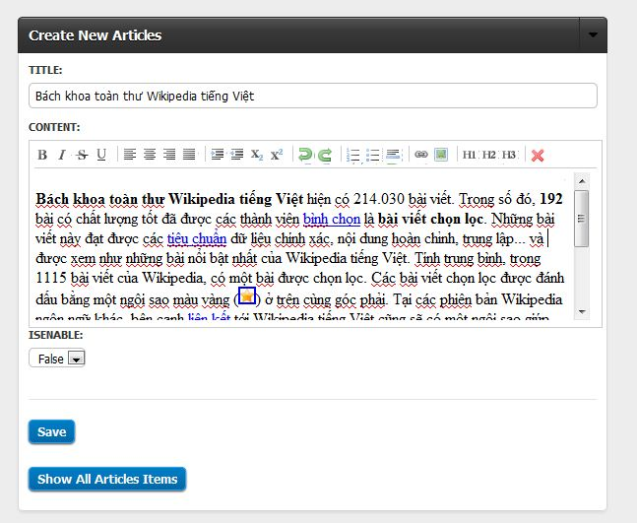

3. Click save button

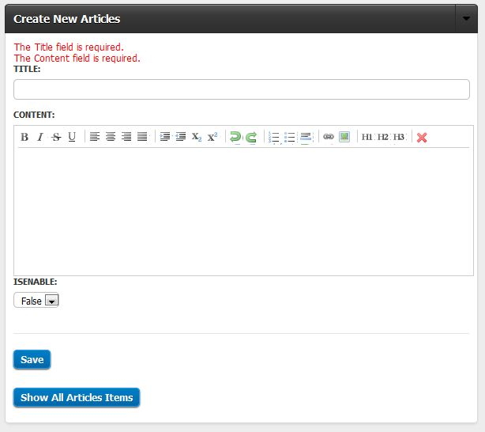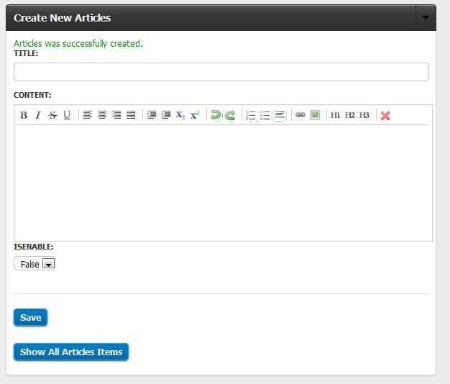

Error: Information missing

Add successful

## Add department

1. Click add button

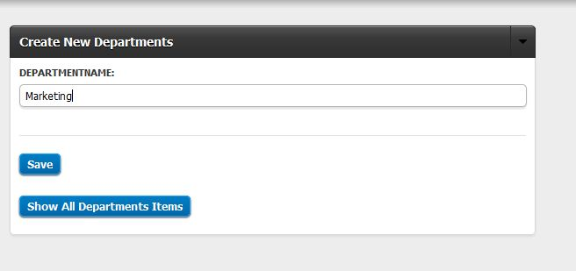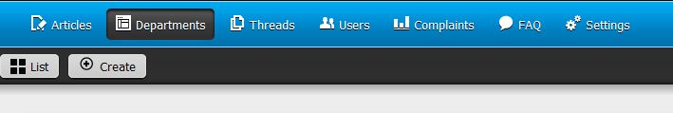

3. Click save button

2. Input information

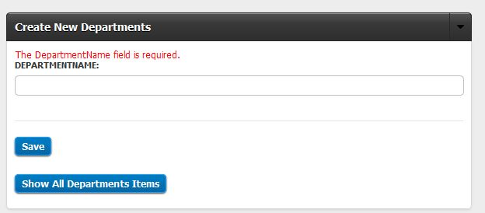

Error: department name is missing

## Add FAQ

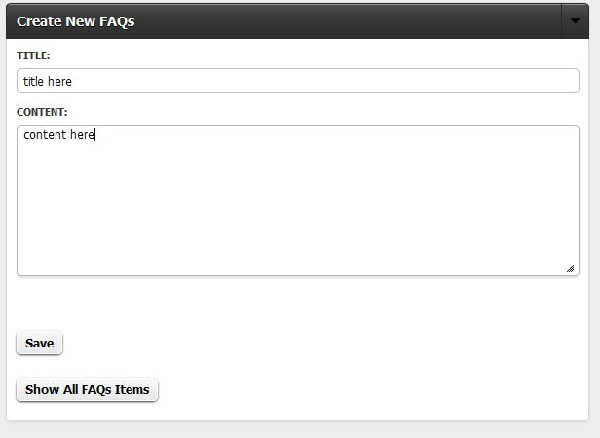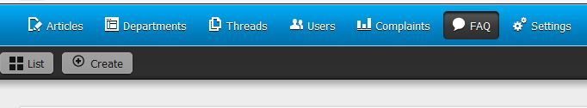

3. Click save button

2. Input FAQ information

1. Click create

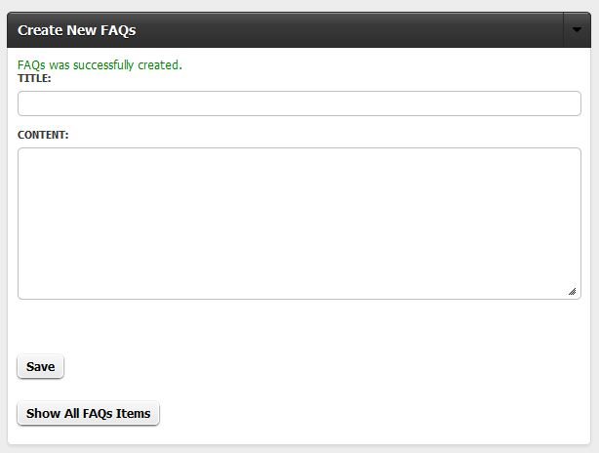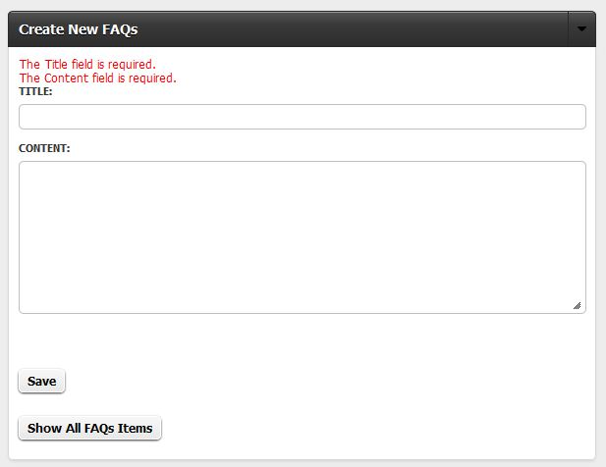

Add FAQ successful

Error: information is missing

## Add thread

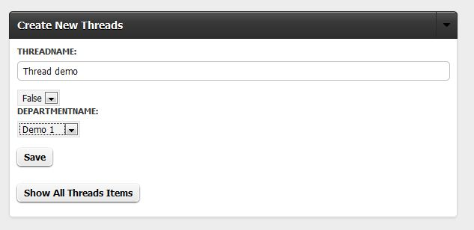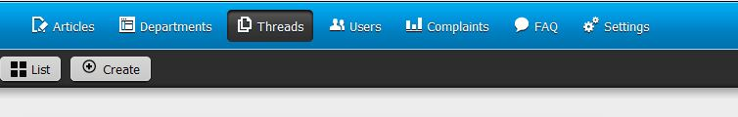

5. Click save button

4. Select department

3. Select thread status

2. Enter thread name

1. Click create

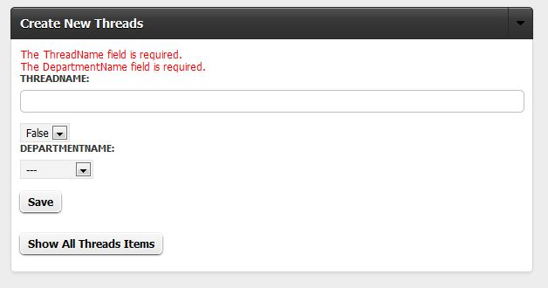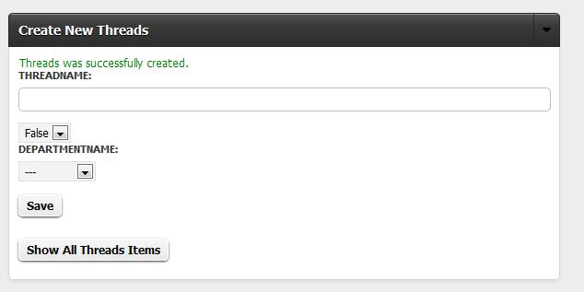

Error: information is missing

Insert successful

## Add **user**

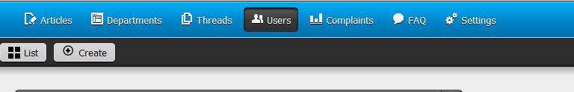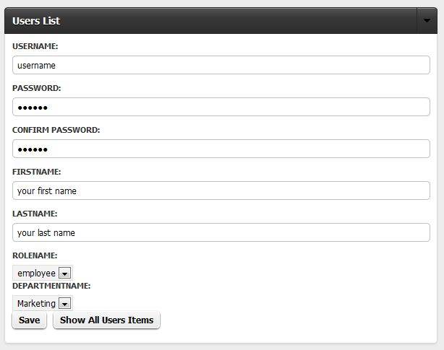

4. Click save button

3. Select user role & department

2. Enter user information

1. Click Create button

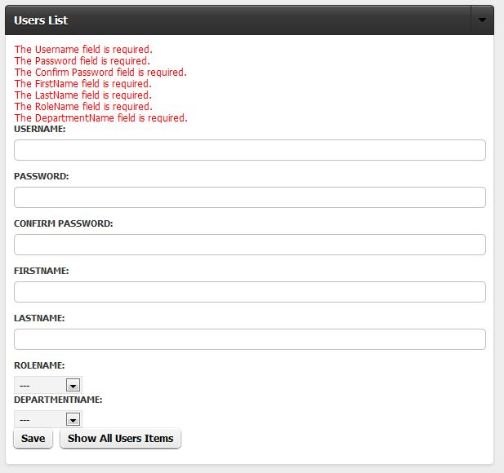

Error: information is missing

## Add complaint

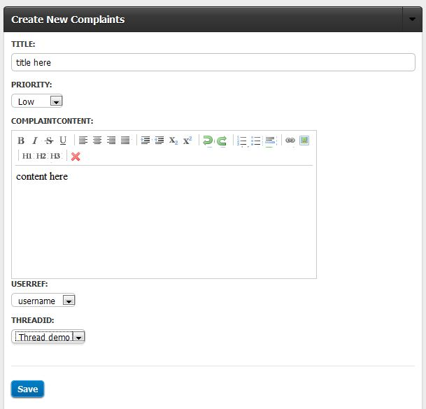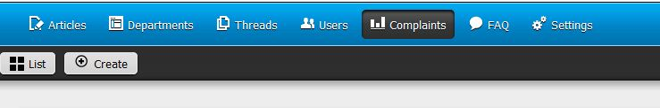

5. Click save button

4. Select technician name & thread name

3. Select priority level

2. Enter complaint information

1. Click create button

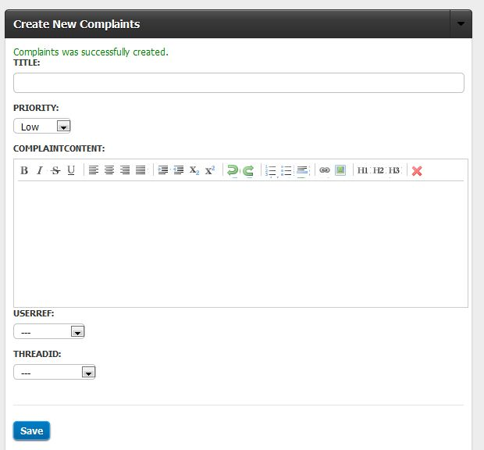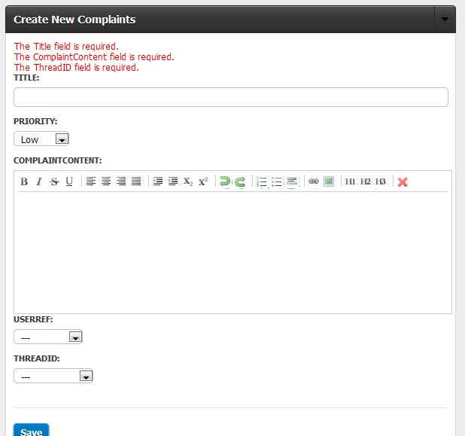

Create successful

Error: information is missing

## Change password

1. Click change password button

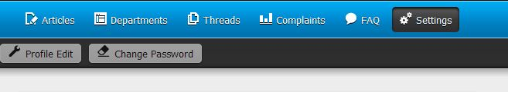

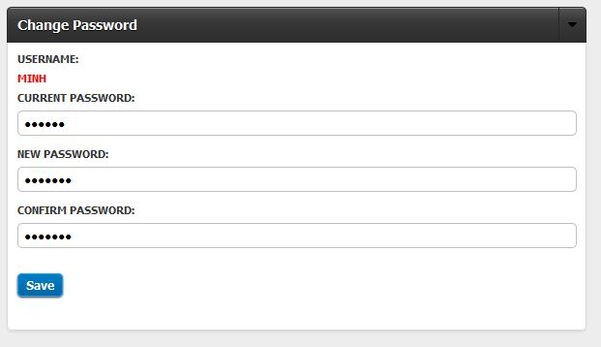

2. Input current password & new password and confirm password

3. Click save button

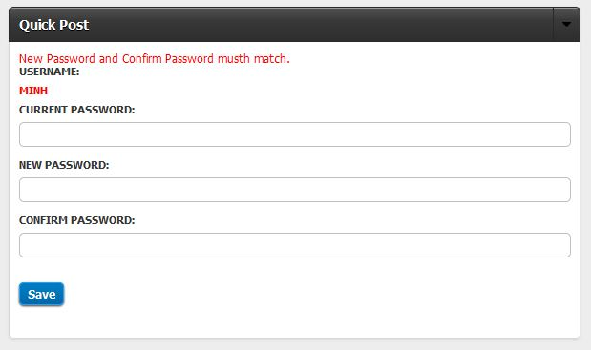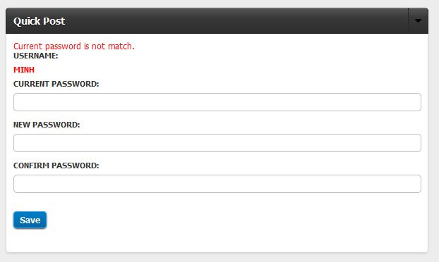

Error: new password and confirm password is not match

Error: information is not matchh

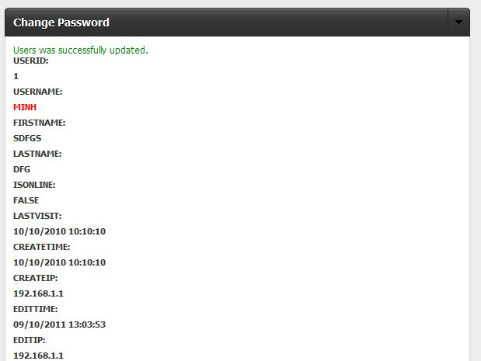

Update password successful

## Disable & enable article

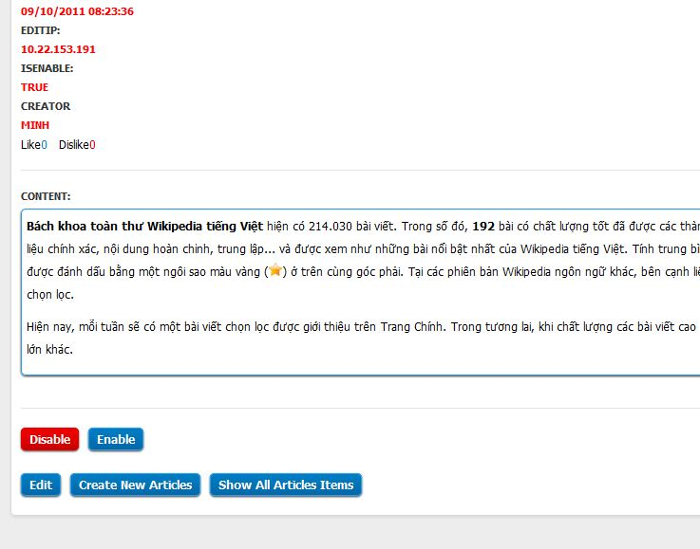

Click disable or enable to disable & enable article

## Disable & enable department

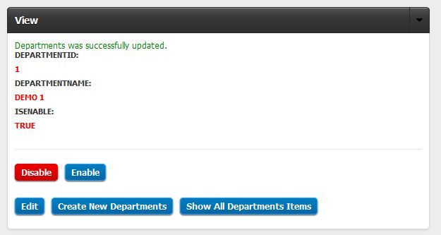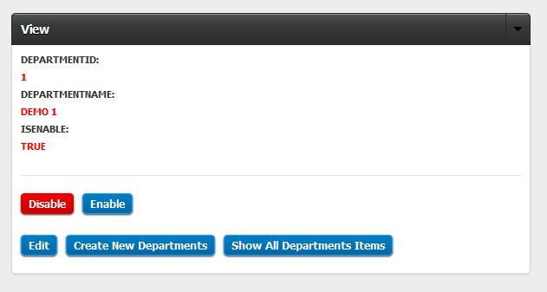

Click disable or enable to disable & enable department

Enable department successful

## Disable user

Click disable or enable to disable & enable user

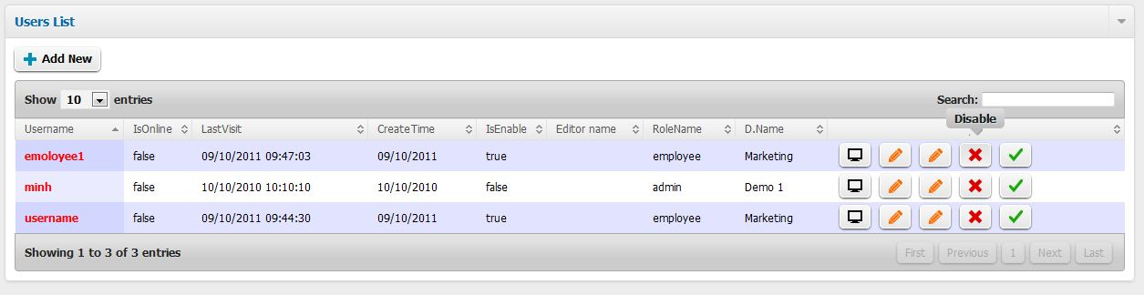

## Edit article

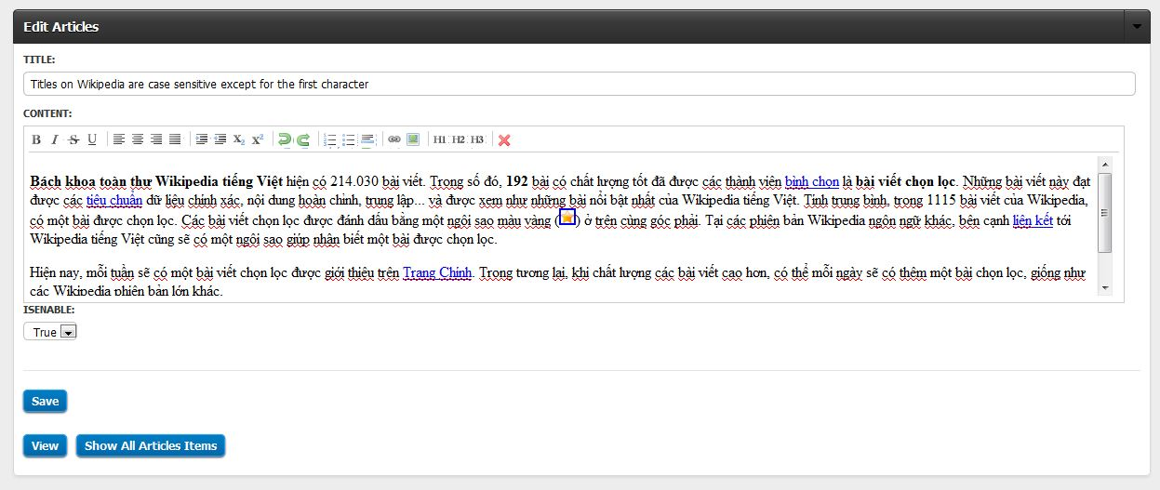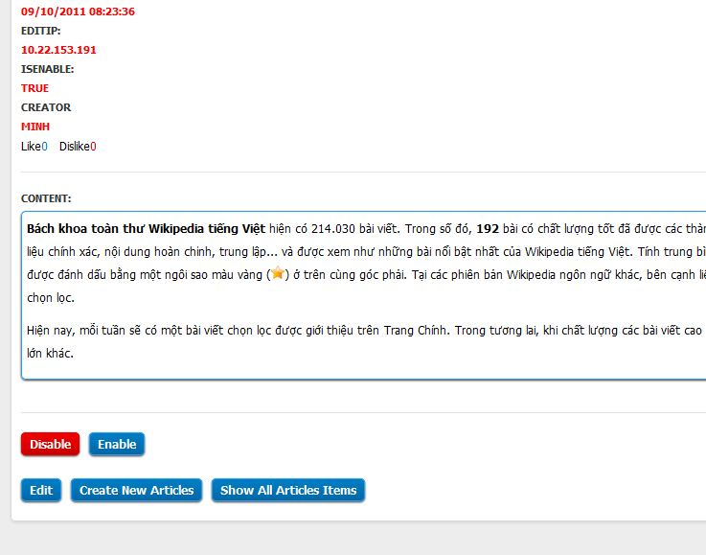

3. click save button

2. Modify information

1. Click edit button

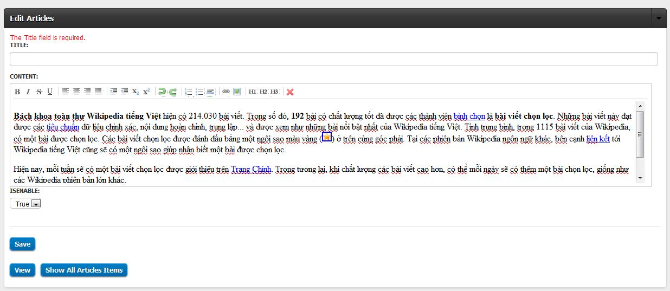

Error: information is missing

## D:\Class\SEM IV\E-Project\eproject-mantech\use_guide_img\edit department 2.JPGD:\Class\SEM IV\E-Project\eproject-mantech\use_guide_img\edit departmnt.JPGEdit department

1. Click edit button

2. Modify information

3. Click save button

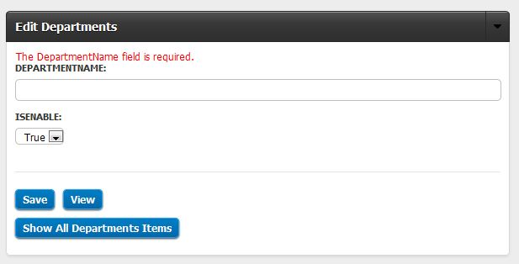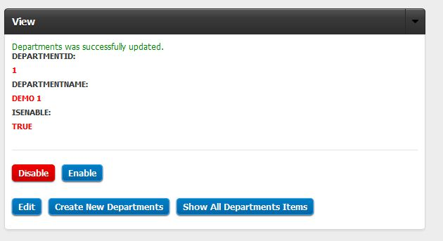

Error: information is missing

Edit successful

## Edit FAQ

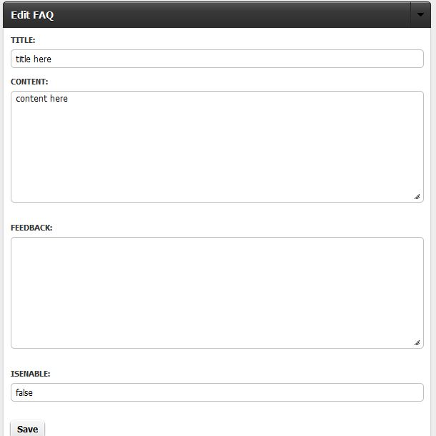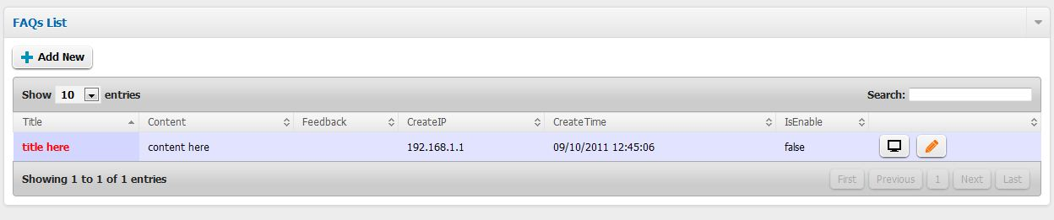

3. Click save button

2. Modify information

1. Click edit button

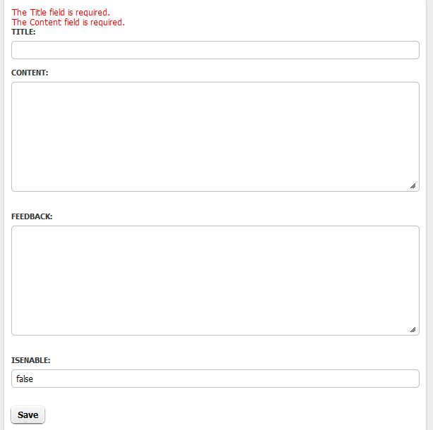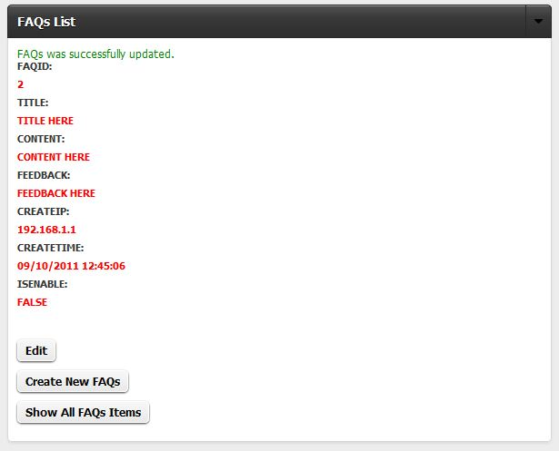

Error: information is missing

Edit successful

## Edit profile

1. Click profile edit button

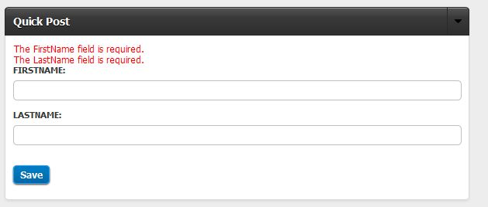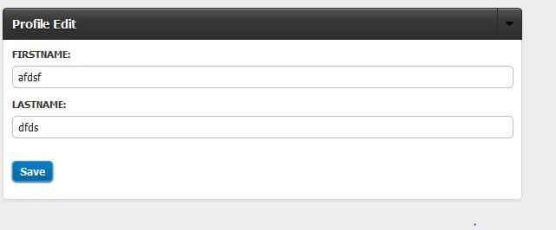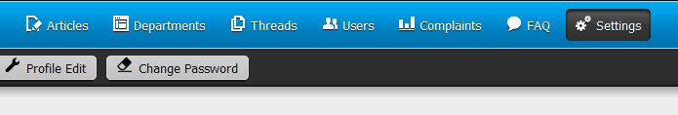

3. Click save button

2. Modify information

Error: information is missing

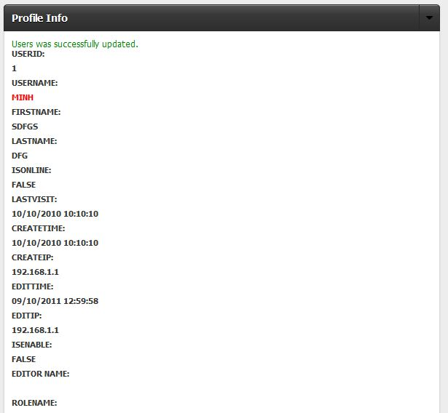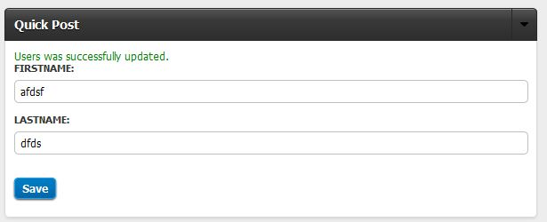

Edit successful

Edit successful

## Edit thread

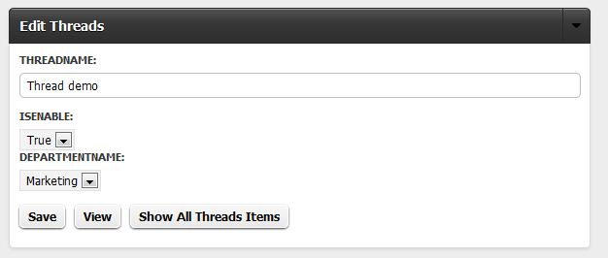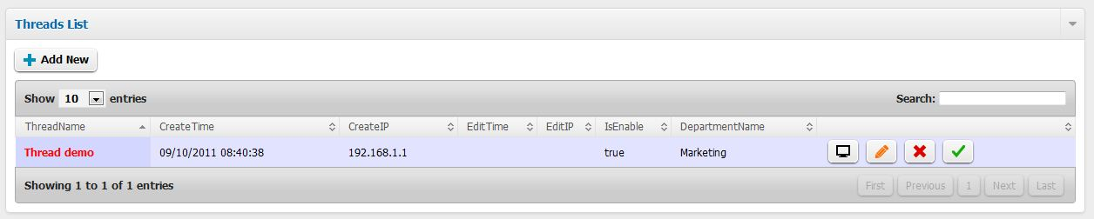

3. Click save button

2. Modify information

1. Click edit button

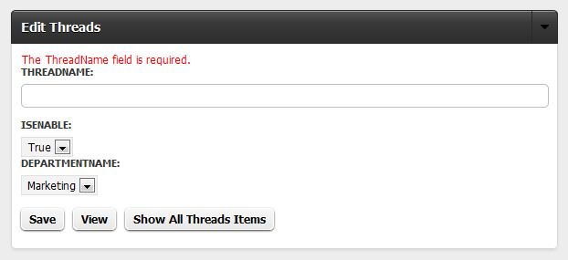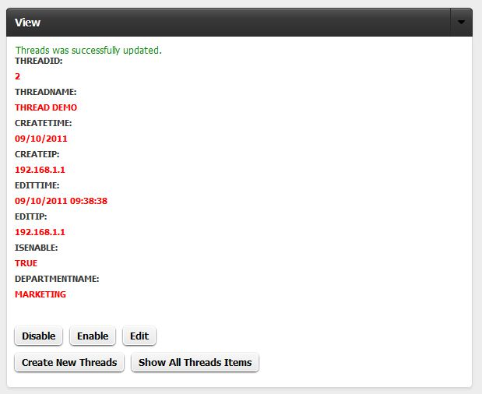

Error: information is missing

Edit successful

## Edit user

1. Click edit button

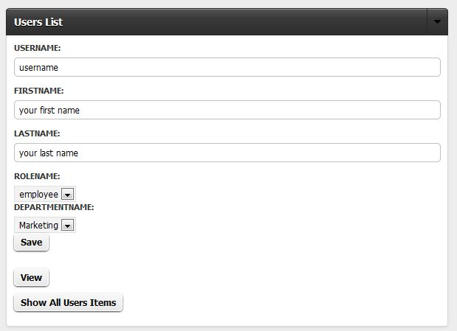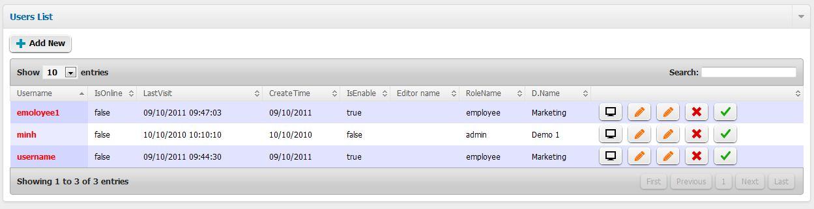

3. Click save button

2. modify information

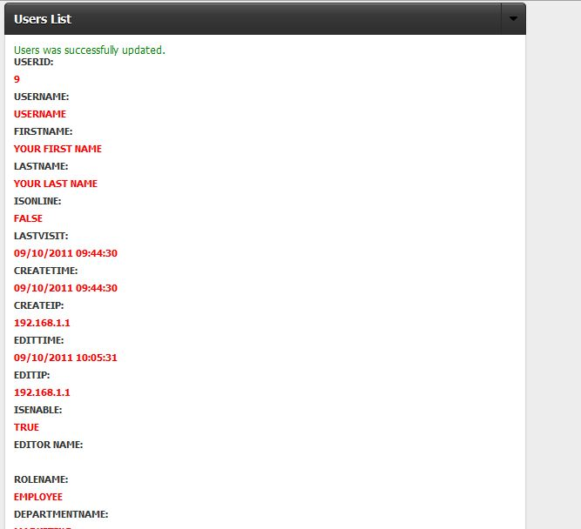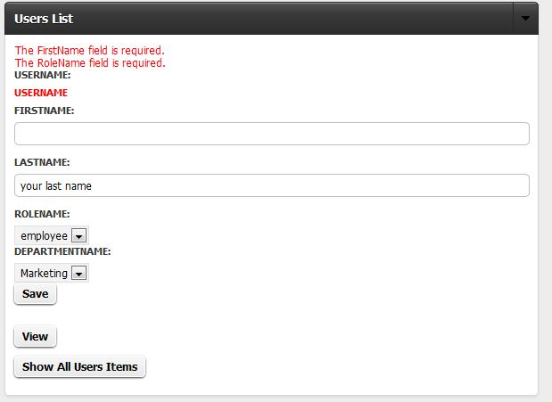

Edit successful

Error: Information is missing

## D:\Class\SEM IV\E-Project\eproject-mantech\use_guide_img\enable user.JPGEnable & disable user

Click Disable or enable to disable or enable user

## List article

1. Click List button

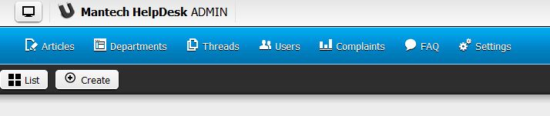

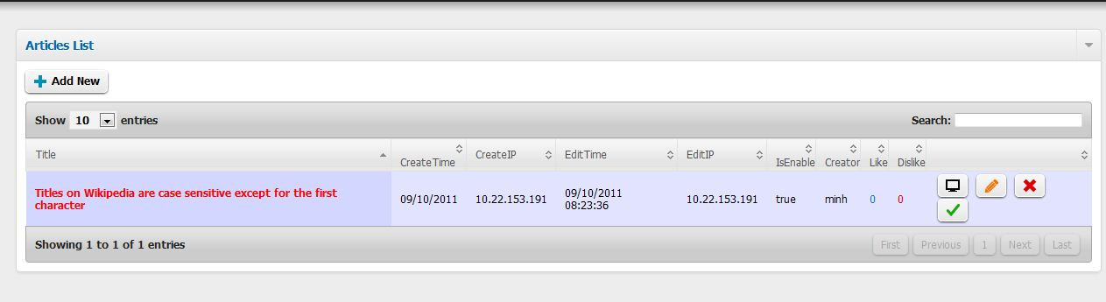

List of articles

## List department

1. Click List button

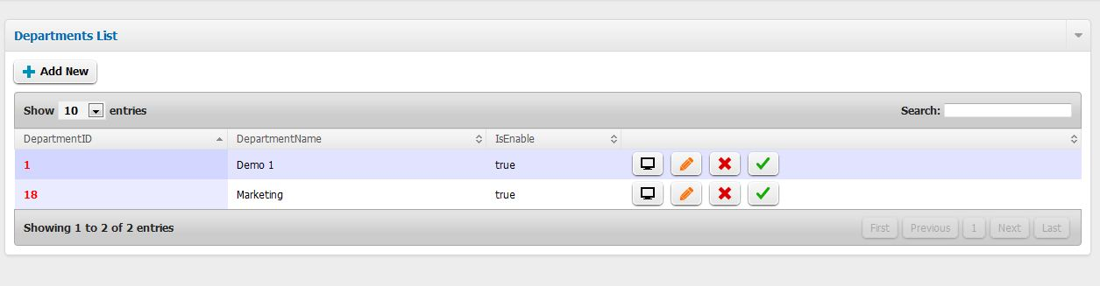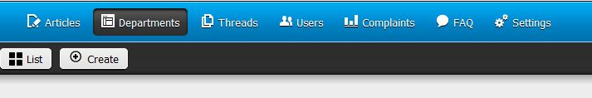

List of departments

## List FAQ

1. Click List button

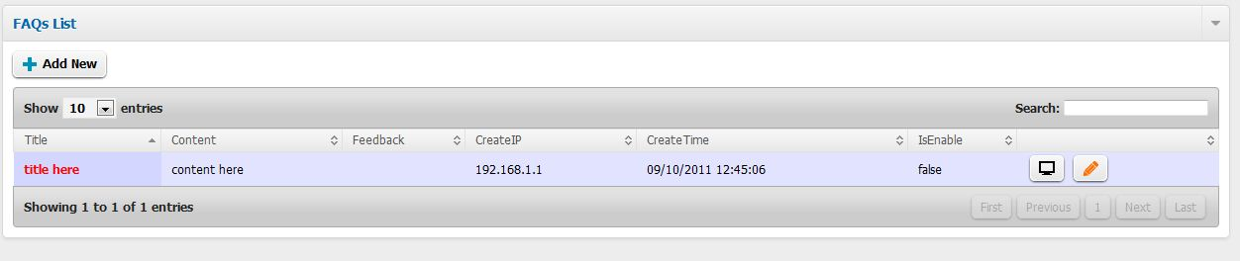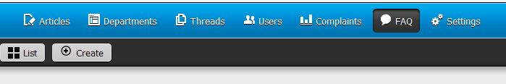

List of FAQs

## List thread

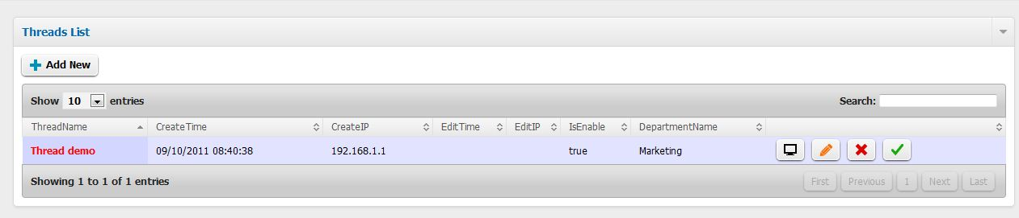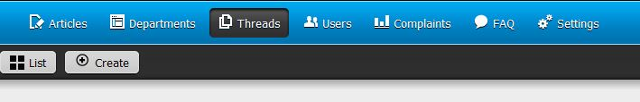

List of threads

1. Click List button

## List user

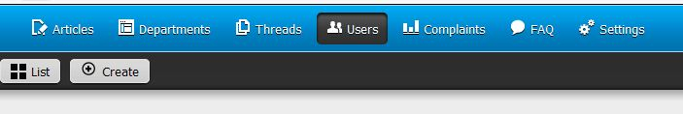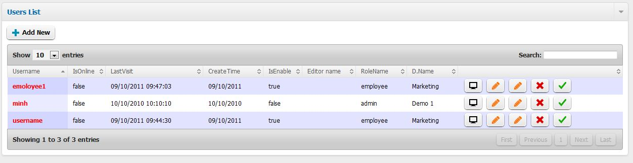

List of users

1. Click List button

## Login

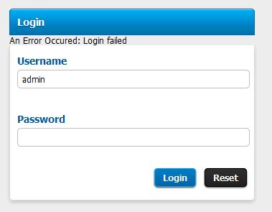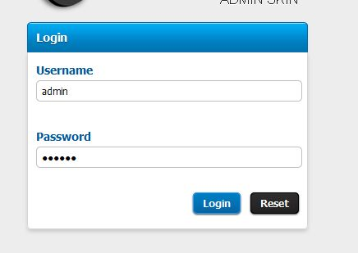

2. Click Login button

1. Input username & password

Error: username or password is not correct

## Reset password

1. Click reset password button

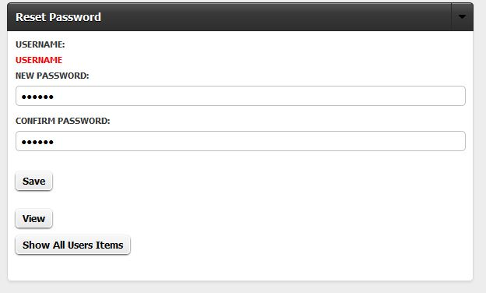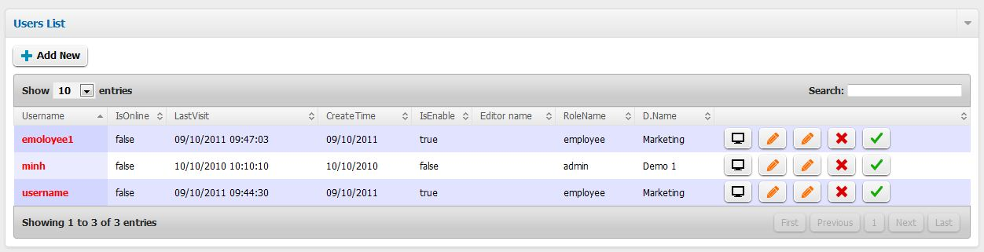

3. Click save button

2. Enter new password and confirm password

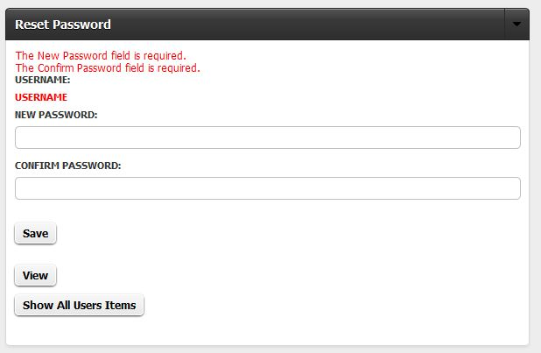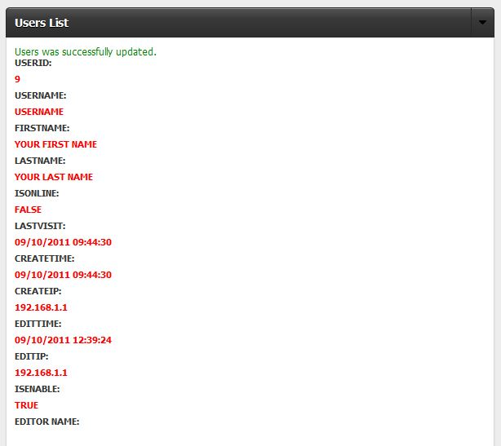

Error: information is missing

Reset password successful

## View article

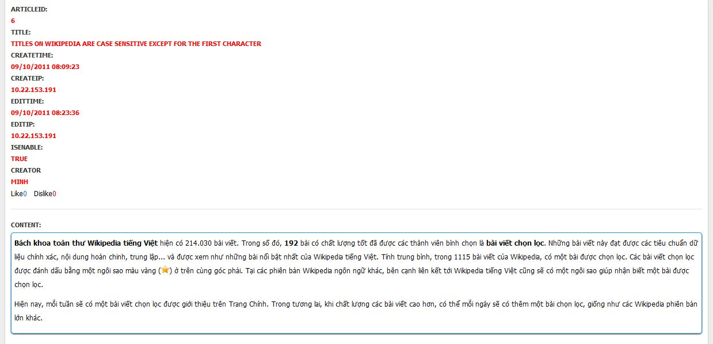

## View department

1. Click view button

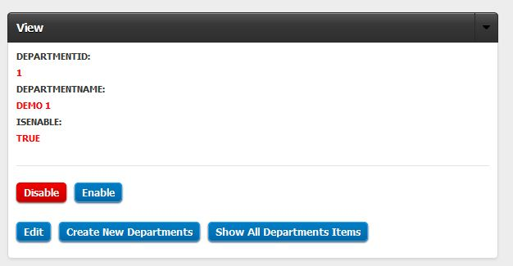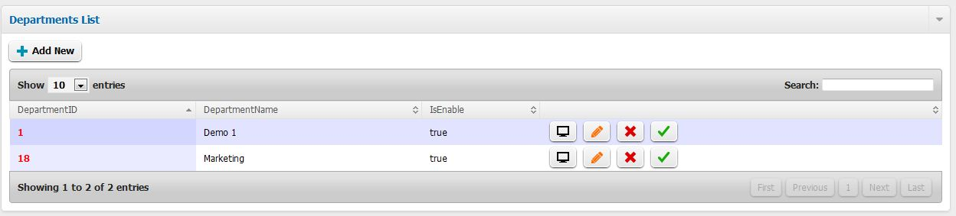

Department information

## View FAQ

1. Click View button

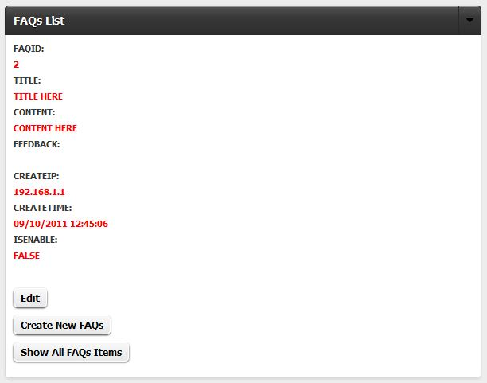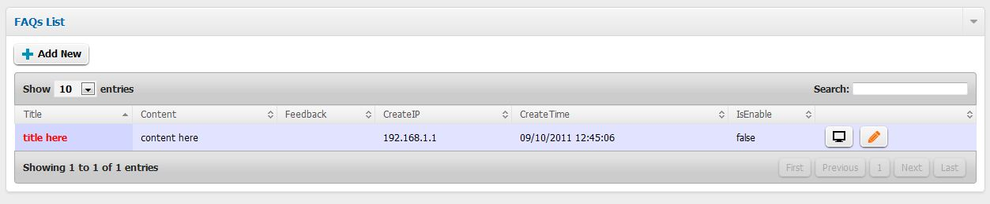

FAQ information

## View profile

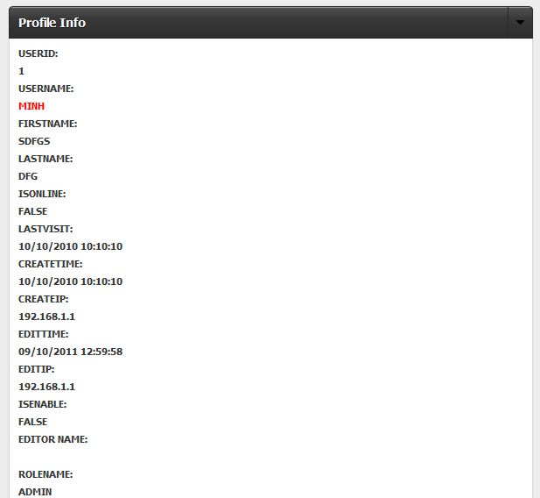

Profile information

## D:\Class\SEM IV\E-Project\eproject-mantech\use_guide_img\view thread 2.JPGD:\Class\SEM IV\E-Project\eproject-mantech\use_guide_img\view thread 1.JPGView thread

1. Click View button

Thread information

## View user

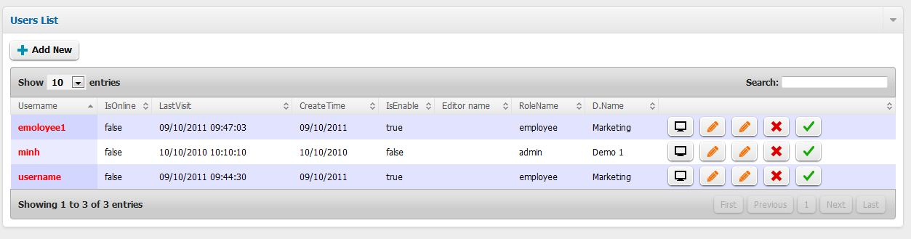

1. Click View button

# Employee

## D:\Class\SEM IV\E-Project\eproject-mantech\use_guide_img\emp_add complaint 2.JPGD:\Class\SEM IV\E-Project\eproject-mantech\use_guide_img\emp_add complaint 1.JPGAdd new complaint

1. Click Create button

2. Enter information

3. Click save button

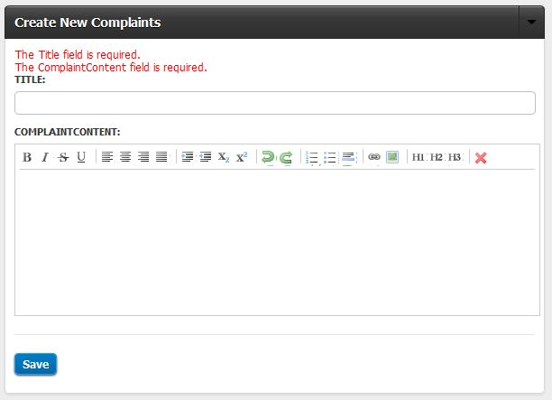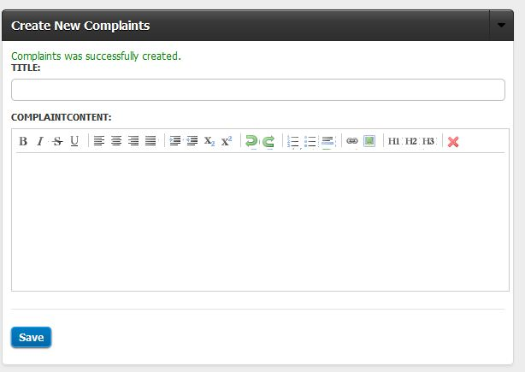

Error: information is missing

Create successful

## Add new FAQ

1. Click Create button

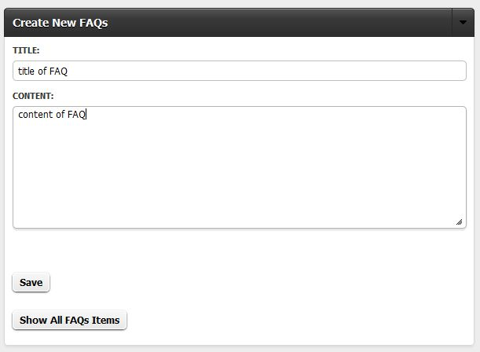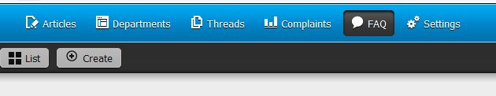

3. Click save button

2. Enter information

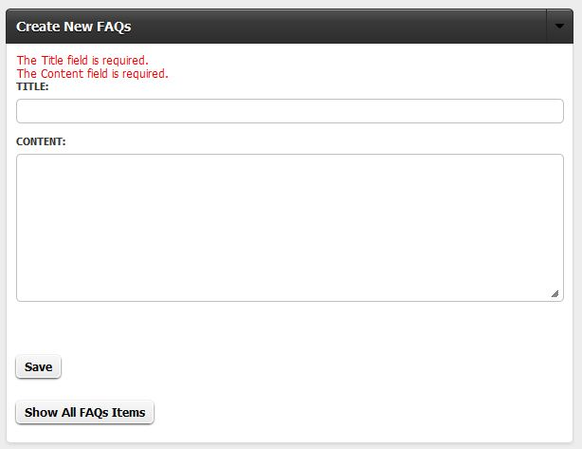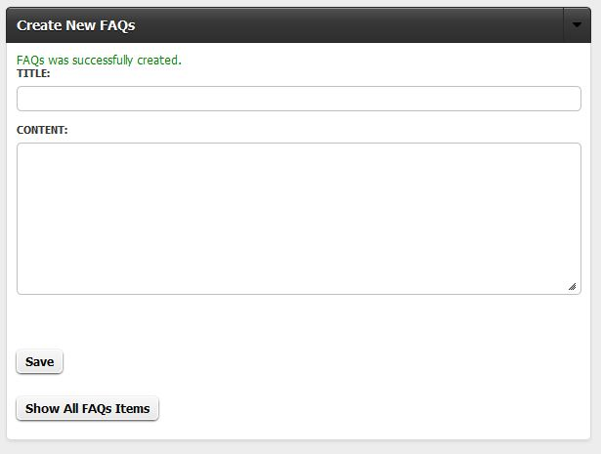

Error: information is missing

Create successful

## Like & dislike article

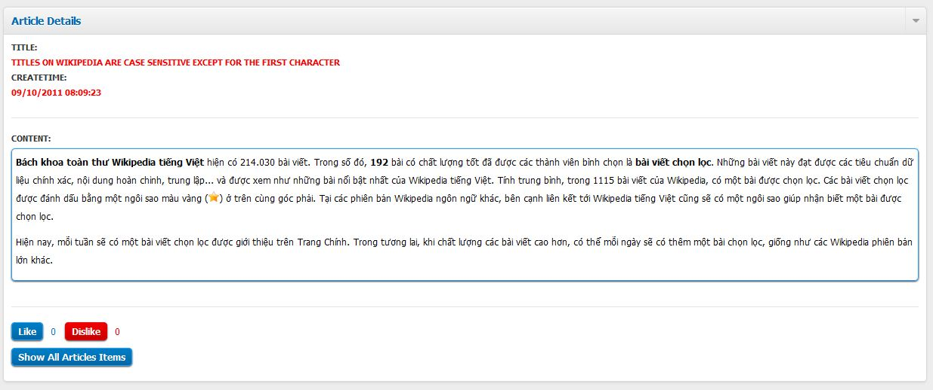

Click like or dislike button

## List article

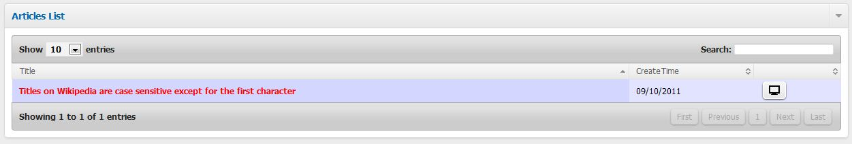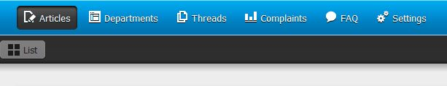

1. Click List button

List of articles

## List complaint

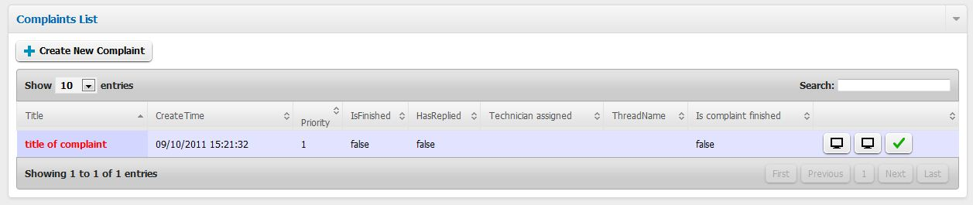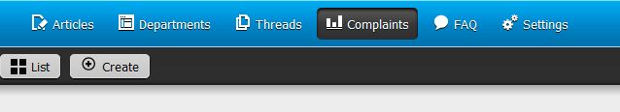

1. Click List button

List of complaints

## List department

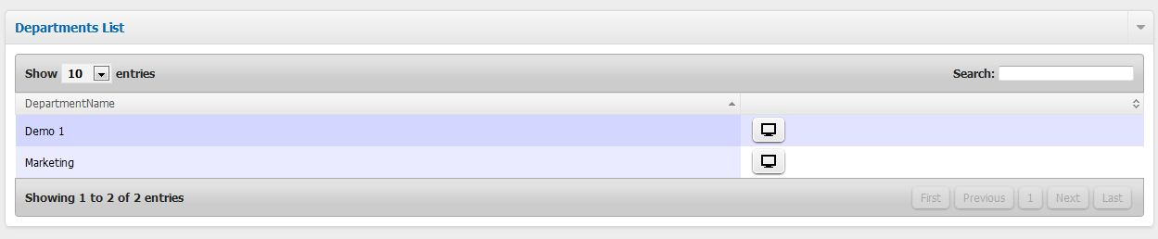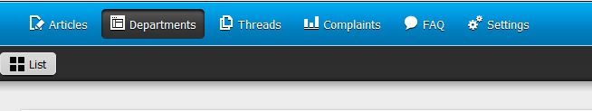

1. Click List button

List of departments

## List FAQ

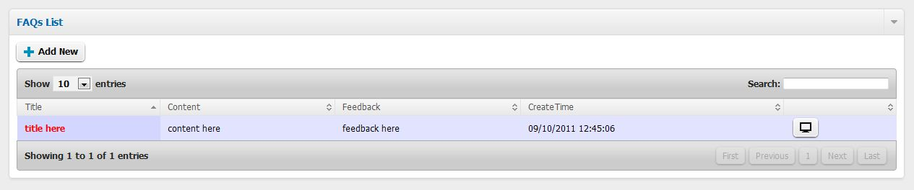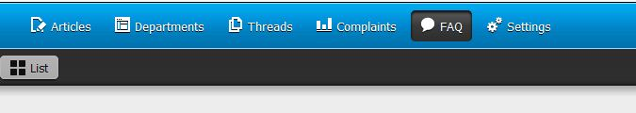

1. Click List button

List of FAQs

## D:\Class\SEM IV\E-Project\eproject-mantech\use_guide_img\emp_list thread 2.JPGD:\Class\SEM IV\E-Project\eproject-mantech\use_guide_img\emp_list thread.JPGList thread

List of threads

1. Click List button

## Set complaint to finished

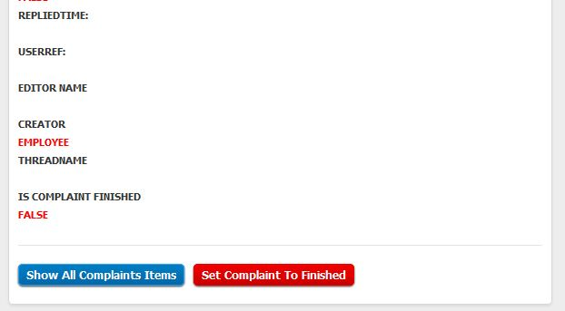

1. Click Set Complaint To Finished button

## D:\Class\SEM IV\E-Project\eproject-mantech\use_guide_img\emp_view article 2.JPGD:\Class\SEM IV\E-Project\eproject-mantech\use_guide_img\emp_view article 1.JPGView article

1. Click View button

Article information

## D:\Class\SEM IV\E-Project\eproject-mantech\use_guide_img\emp_view comp answers 3.JPGD:\Class\SEM IV\E-Project\eproject-mantech\use_guide_img\emp_view comp answers 2.JPGD:\Class\SEM IV\E-Project\eproject-mantech\use_guide_img\emp_view comp answers 1.JPGView answers of complaint

2. Choose an answers and click view button

1. Click View Answers button

Answer details

## View complaint

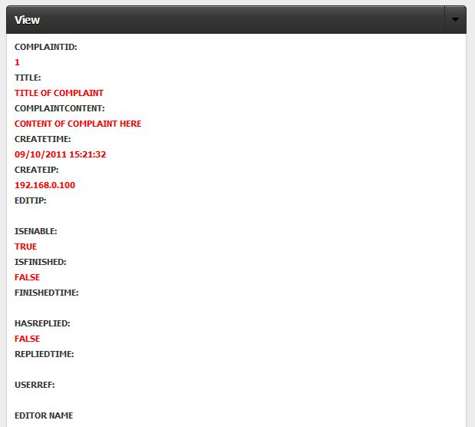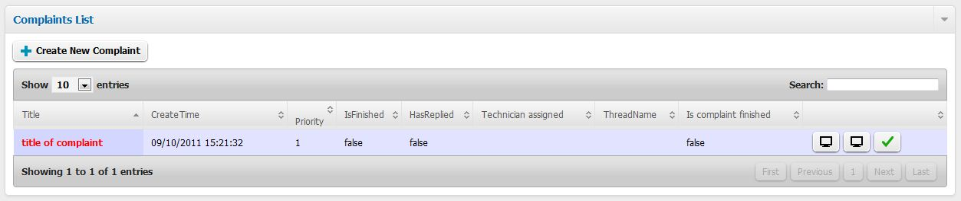

1. Click View button

Complaint details

## View department

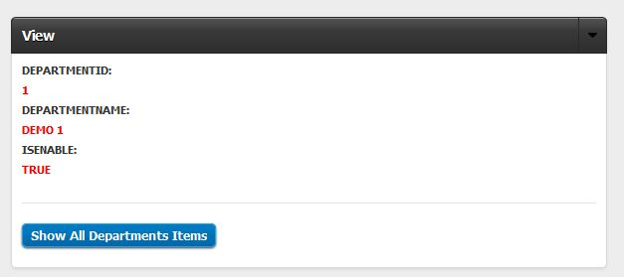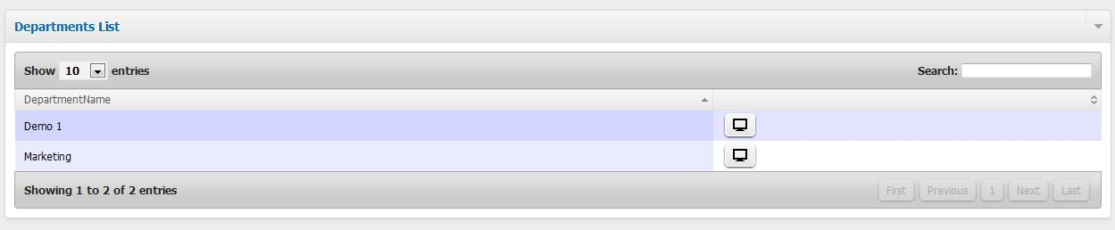

Department details

1. Choose a department and click View button

## View FAQ

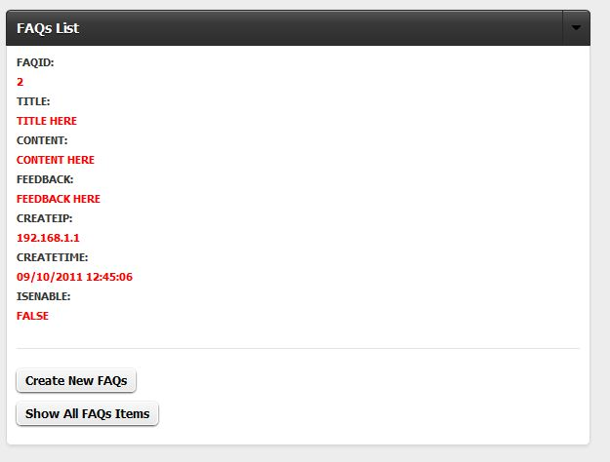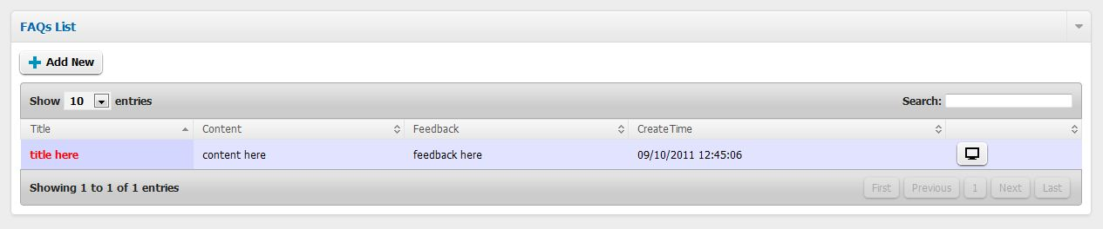

1. Choose a FAQ and click view button

FAQ details

## View thread

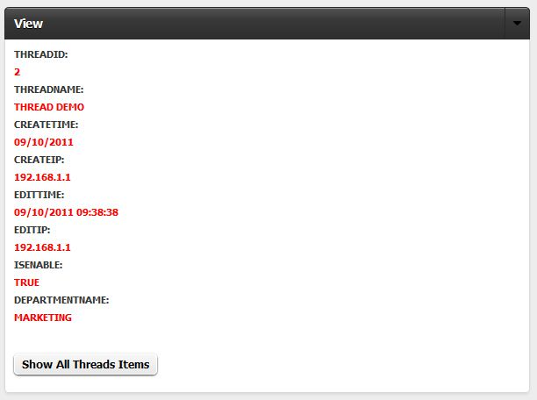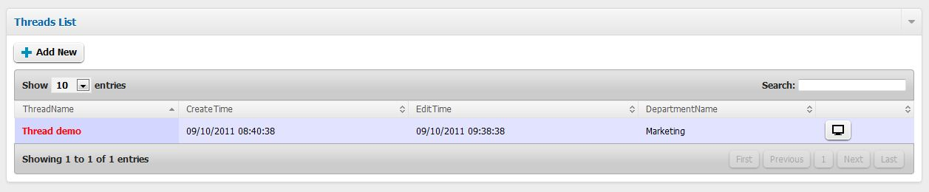

1. Choose a thread and click view button

Thread details

# Technician

## D:\Class\SEM IV\E-Project\eproject-mantech\use_guide_img\tech_add answer 2.JPGD:\Class\SEM IV\E-Project\eproject-mantech\use_guide_img\tech_add answer.JPGAdd new answer to complaint

3. Click save button

2. Enter anwser content

1. Choose a complaint and click Add new answer button

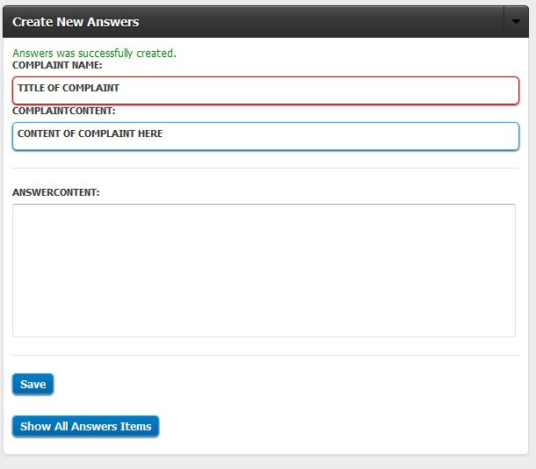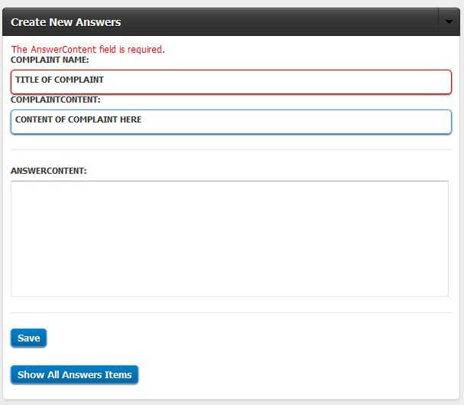

Create answer successful

Error: information is missing

## List complaints

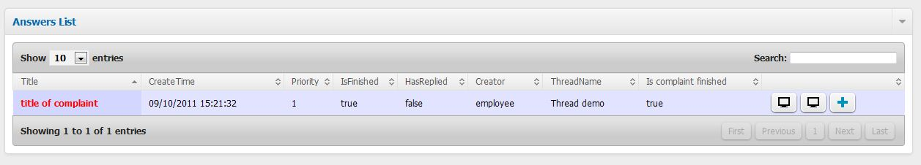

## D:\Class\SEM IV\E-Project\eproject-mantech\use_guide_img\tech_dis enable answer.JPGDisable & enable answer

Click disable or enable button to disable or enable answer

## D:\Class\SEM IV\E-Project\eproject-mantech\use_guide_img\tech_edit answer 2.JPGD:\Class\SEM IV\E-Project\eproject-mantech\use_guide_img\tech_edit answer 1.JPGEdit answer

3. Click save button

2. Modify answer content

1. Choose an answer and click edit button

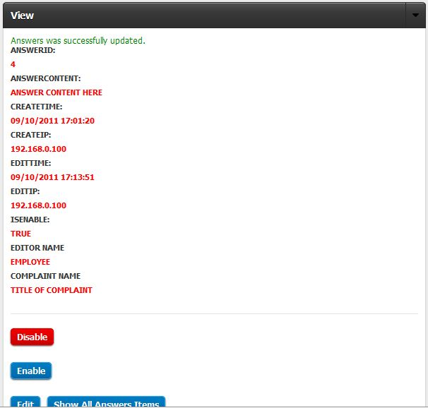

Edit answer successful

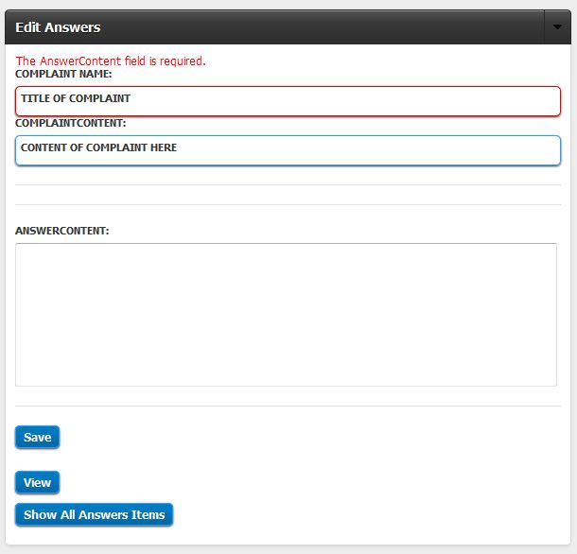

Error: information is missing

## View answer

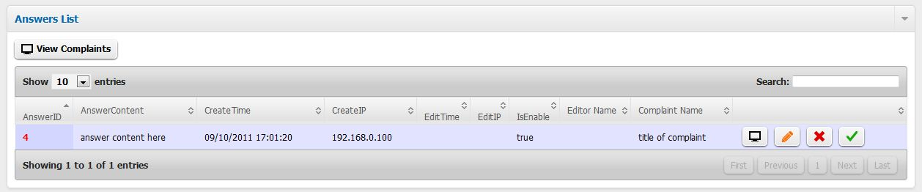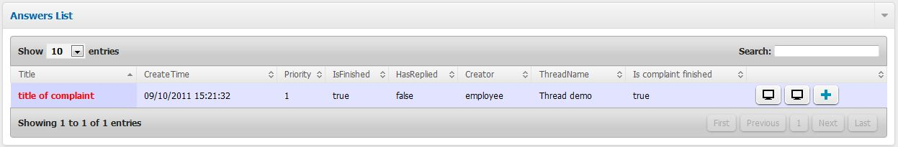

2. In answers list, choose an answer and click view button

1. Choose a complaint and click View answers button

## View complaints

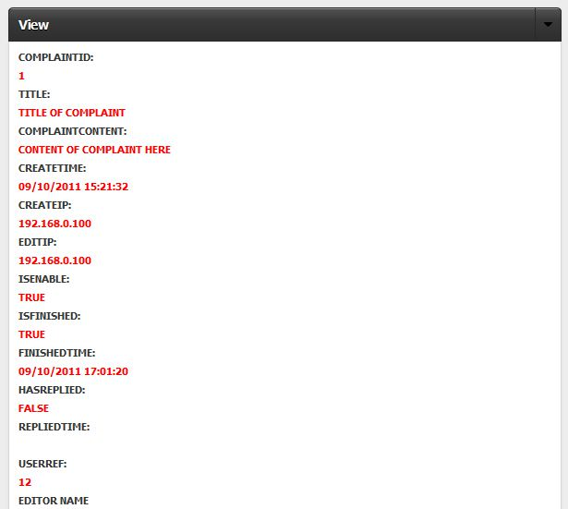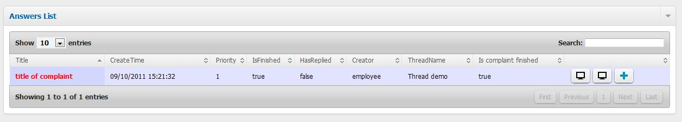

1. In complaints list, choose a complaint and click view button

Complaint details